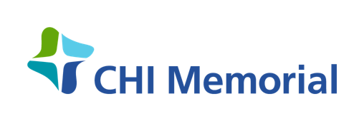
Community Benefit Funding Application
Fiscal Year July 1, 2023—June 30, 2024

NOTICE: This form must be completed
for funding requests to be considered.
Thank you for your submission. The committee meets throughout the year to determine eligibility and availability of funds throughout the year.
Application Date: Select a date here. Funding Request: Type a dollar-amount here.

Organization: Type the organization title here.

Address: Type the organization address here.
Contact: Type the organization contact name here.
Phone: Type the organization contact ten-digit phone number here.
E-Mail: Type the organization contact e-mail address here.

Organization Mission/Vision: Type the organization mission and/or vision statement(s) here. Organization Type: ☐ Non-Profit ☐ Not a Non-Profit
Organization Status: ☐ Currently Receiving CHI Memorial Funding ☐ Not Currently Receiving CHI Memorial Funding
Organization Funding History: Describe past, present, and future funding from CHI Memorial to the organization.

* Responses may be completed separately and attached to this application document.

Program/Project: Type the program/project title here.

*Explain the overall goal of the program/project pertaining to the CHI Memorial funding request:
Type an explanation here or attach an explanation to this application.

*Explain how the program/project aligns with CHI Memorial’s Mission and Core Values (view Guidelines):
Type an explanation here or attach an explanation to this application.

Select a CHI Memorial Funding Priority item for the program/project (view Guidelines):

☐ Access to Affordable Health Care and Insurance ☐ Mental/Behavioral Health ☐Affordable/Healthy Housing
☐ Substance Use Disorder ☐ Prevention and Education ☐Violence ☐ Obesity ☐ Food Insecurity ☐ Chronic diseases

*Explain how the program/project intends to specifically address the CHI Memorial Funding Priority item:
Type an explanation here or attach an explanation to this application.

*List all outcomes and metrics that measure/will measure the success of the program/project:
List the items here or attach a list to this application; please be specific and consider that CHI Memorial requires all funded organizations to submit an annual Funding Evaluation form to measure the success of the program/project.

*Who will be served and how many will be served by this program/project?
Describe the target population and the volume of the target population here, or attach a description to this application.

*Please attach a program/project line-item budget and respond to the following two inquiries:

What percentage of the funding will remain in the Chattanooga regional community? Select a percentage range.
If granted, then what month during the fiscal year (July 1 – June 30) will funding be needed? Select a calendar month.

If the program/project requests sponsorship of an event, then respond to the following two inquiries:

Will a CHI Memorial representative need to be present during the event? ☐ Yes ☐ No
What percentage of the proceeds will benefit the organization versus cover event expenses? Select a percentage range.

FOR INTERNAL USE ONLY: ☐ Approved ☐ Not Approved APPLICATION ID: Type ID here.

